# Python for Data Science, AI & Development

## Module 1: Python Basics

This module teaches the basics of Python and begins by exploring some of the different data types such as integers, real numbers, and strings. Continue with the module and learn how to use expressions in mathematical operations, store values in variables, and the many different ways to manipulate strings.

**Learning Objectives**

* Demonstrate an understanding of types in Python by converting or casting data types such as strings, floats, and integers.
* Interpret variables and solve expressions by applying mathematical operations.
* Describe how to manipulate strings by using a variety of methods and operations.
* Build a program in JupyterLab to demonstrate your knowledge of types, expressions, and variables.
* Work with, manipulate, and perform operations on strings in Python.

### M1-S1: About the course

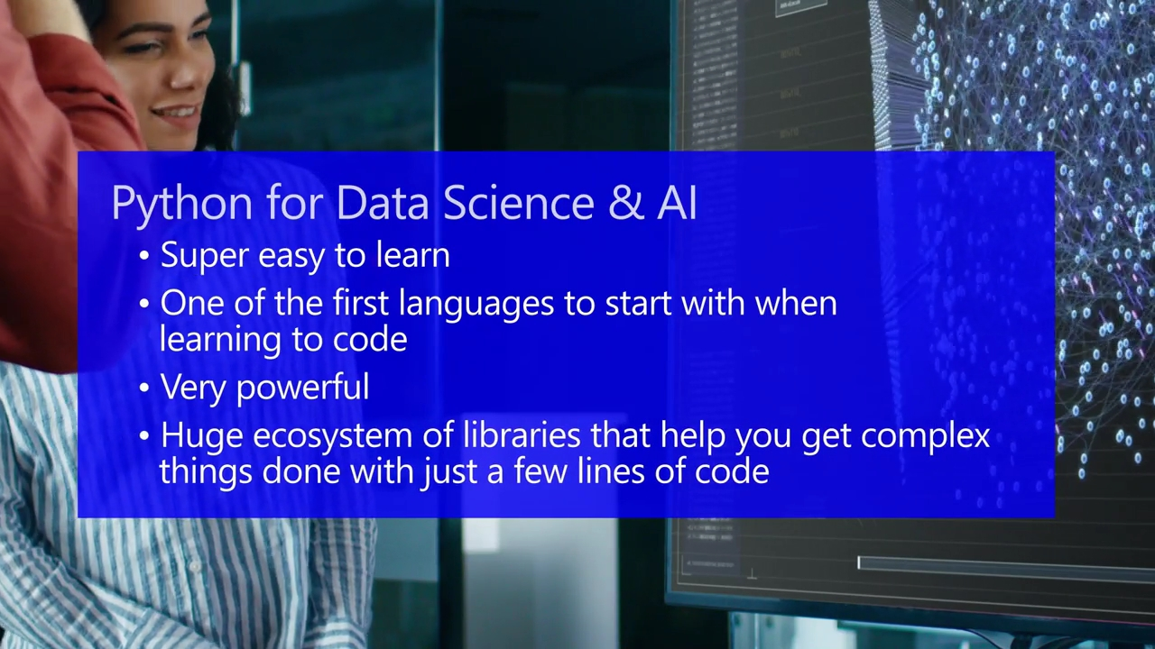Hello. I'm Joseph, and I will be your instructor for this course. You made the right choice. If there's just one programming language, I had to learn for data science and AI, it would unquestionably be Python. The best part is Python is super easy to learn and is often one of the first languages people turn to when trying to learn to code.

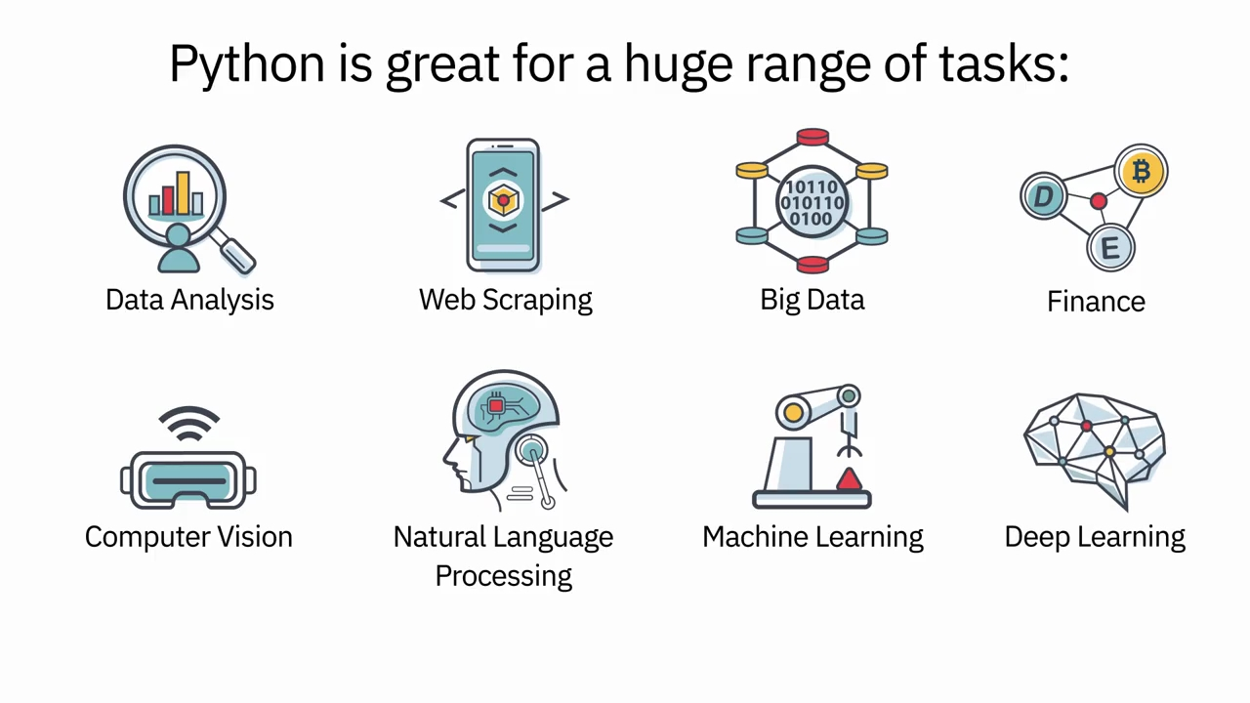Python is very powerful. It has a huge ecosystem of libraries that will help you get the most complex things done with just a few lines of code. Python is great from everything from data analysis, web scraping, to working with big data, finance, computer vision, natural language processing, machine learning, deep learning, and much more. Python can do anything you can throw at it.

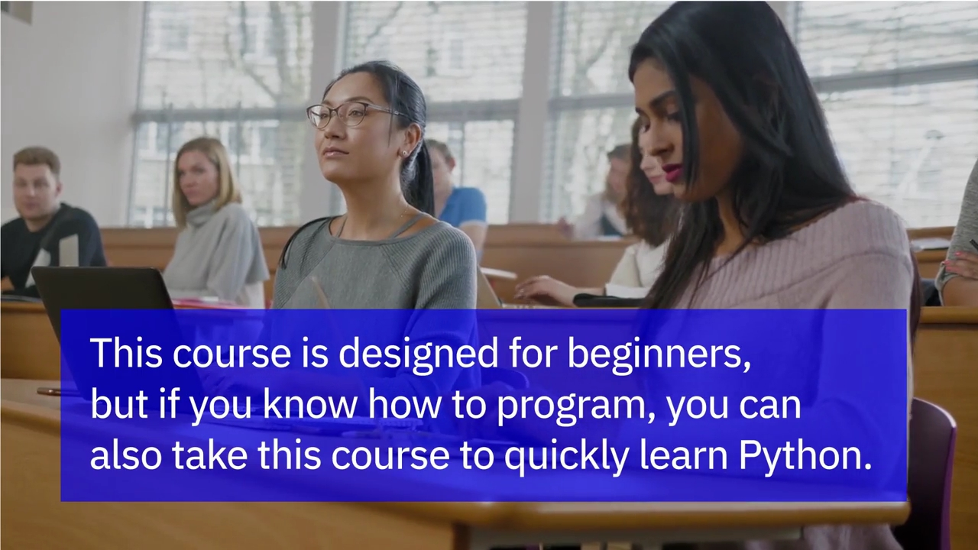This course is designed for beginners, but if you know how to program, you can also take this course and quickly learn Python.

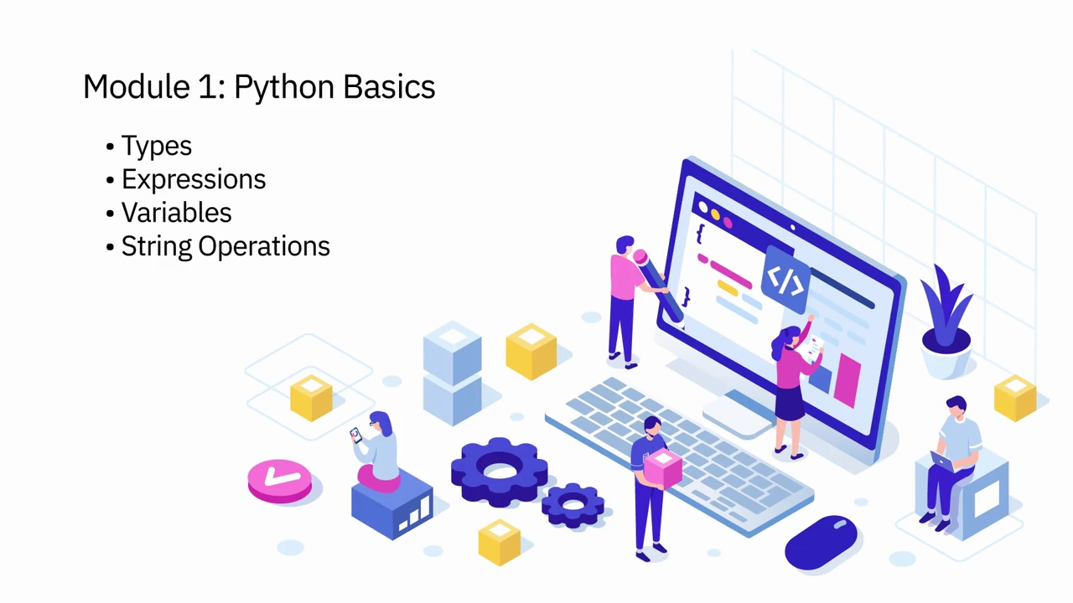In Module 1, you will learn Python basics, including types, expressions, variables, and string operations.

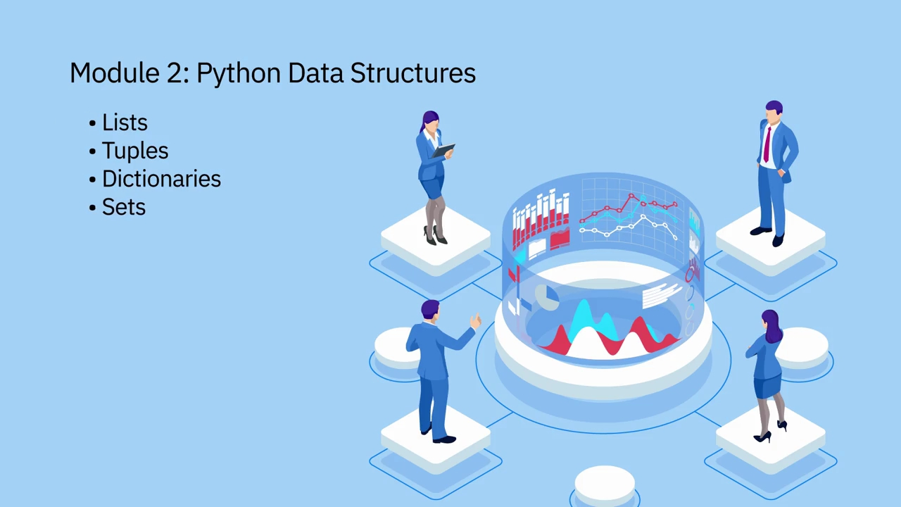In Module 2, you will cover Python data structures, including lists, tuples, dictionaries, and sets.

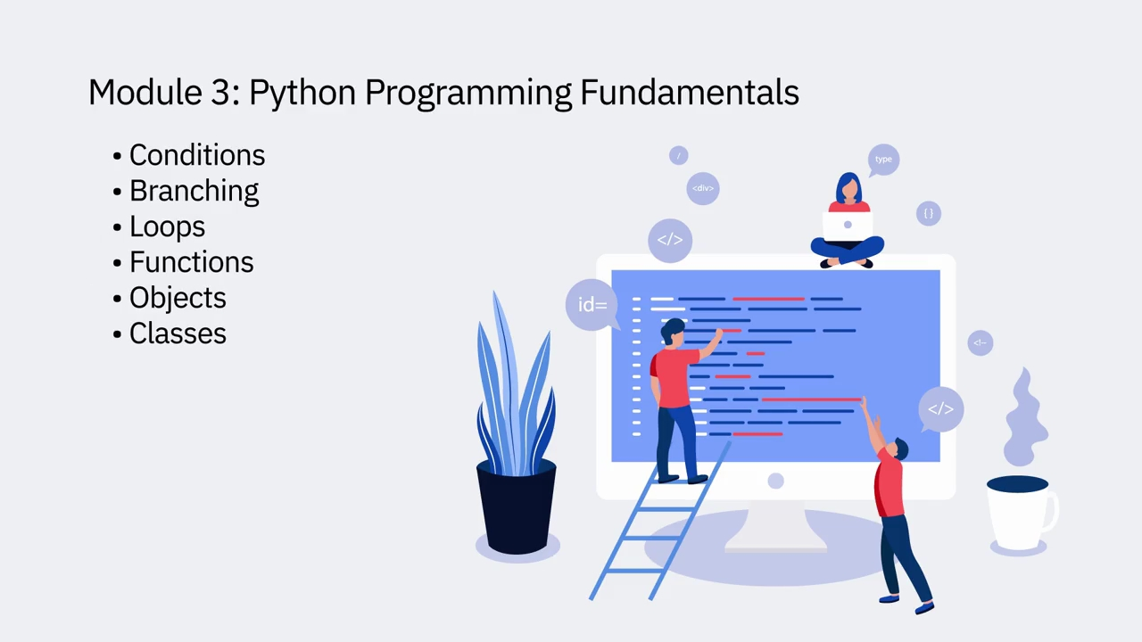In Module 3, I will teach you Python programming fundamentals, such as conditions, branching, loops, functions, and objects and classes.

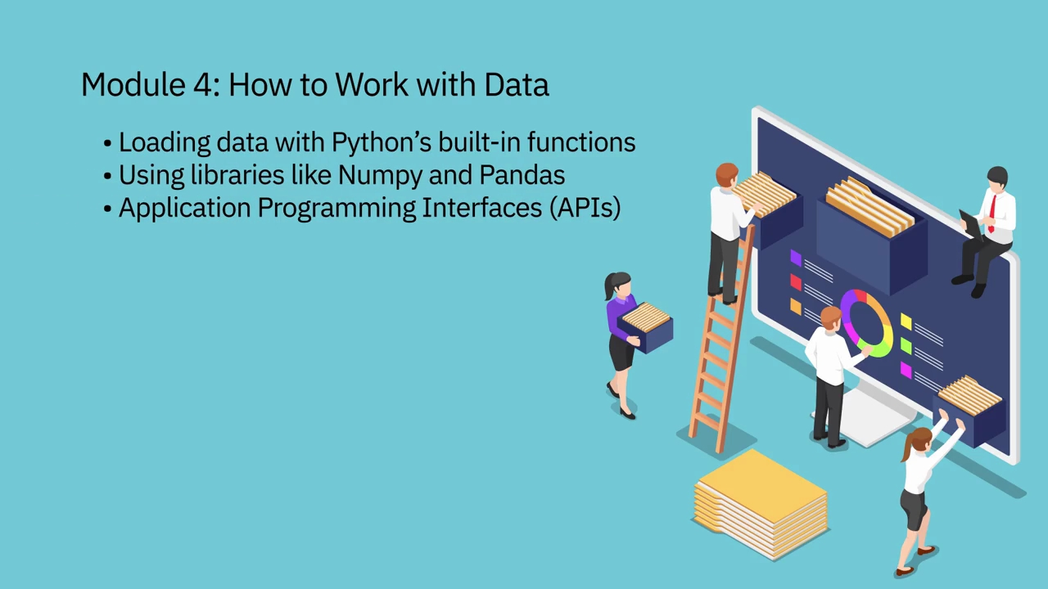In Module 4, I will teach you how to work with data, including loading data with Pythons built-in functions, using popular libraries such as NumPy and Pandas, followed by application programming interfaces, or APIs for short.

You will apply what you learn by doing projects using real-world datasets. If you have any questions or require clarification, feel free to post on the course discussion forum. Good luck and happy learning.